Five Exercise Activities


Hiking: Outdoor activity; can be done in groups. No competition, good aerobic exercise, and you get to enjoy nature as well! 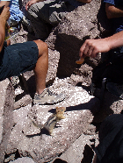

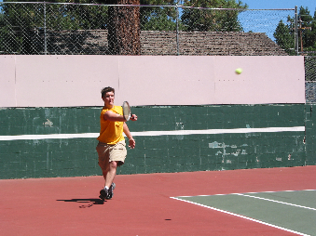
Tennis: Played indoors or outdoors, team or individual. Match style competition requires good coordination and physical training.
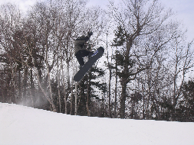
Snowboarding: Fun outdoor activity requires coordination and edge control on a board.
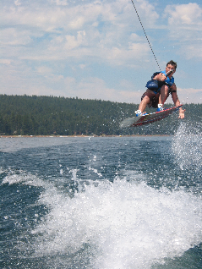
Wakeboarding: Similar to snowboarding, but on water and requires a boat.
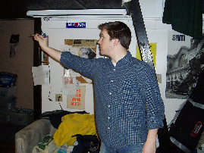
Darts: Precision sport, fine motor control, match style.

